PART A
(Part A: TO BE REFERRED BY STUDENTS)
Experiment No. 03
A.1 AIM:
Apply Data Manipulation language [DML] on the relational model designed and apply certain constrains on the relational model designed.
A.2 Pre requisite:
Fundamental knowledge of DML instructions and the SQL.
A.3 Outcome:
After successful completion of this experiment students will be able to

- Design the relational model with basic constrains.
- Apply the DML commands on the developed relational models.
- Differentiate between DDL and DML and its importance in handling databases.

A.4 Theory:
Data Manipulation Language (DML) statements are used for managing data in database. DML commands are not auto-committed. It means changes made by DML command are not permanent to database, it can be rolled back. DML is short name of Data Manipulation Language which deals with data manipulation, and includes most common SQL statements such as SELECT, INSERT, UPDATE, DELETE etc, and it is used to store, modify, retrieve, delete and update data in database.

1. SELECT: retrieve data from the database.
2. INSERT: insert into a table
3. UPDATE: updates existing data within a table
4. DELETE: delete all records from a database table without deleting the structure of the database.

1. SELECT:
Syntax:
select column_name(s) from table_name; → selects only particular column(s) and all rows
Or
Select * from table_name → selects all columns and all rows of the table mentioned
- INSERT:
Syntax:
insert into table_name (column1, column2, column3,….columnn) values(value1, value2, value3,…..valuen) → used when you want to insert into particular columns not all columns of the table.
Or
insert into table_name values(value1, value2, value3, ….. valuen) → used when you want to insert values into all columns of the table.
- UPDATE:
Syntax:
Update table_name set column= value; → used when you want to update all the rows for the particular column.
Or
Update table_name set column = value, column1=value where somecolumnname = somevalue; → used when you want to update particular row(s)
- DELETE:
Syntax:
delete from table_name; -→ used when you want to delete all the rows of the table.
Or
delete from table_name where somecolumn=somevalue; -→ used when you want to delete only particular row(s) from the table.

A.5 Task: Insert below values into table and apply queries
category_header
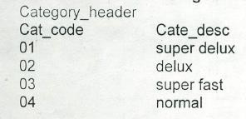
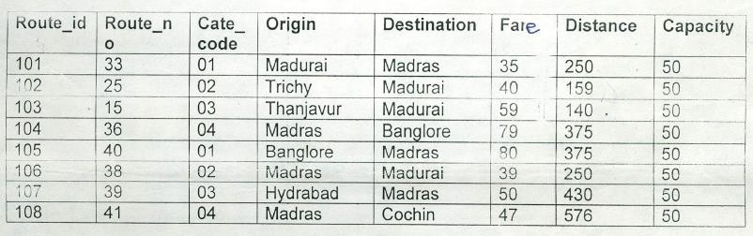
route_header
Place Header:
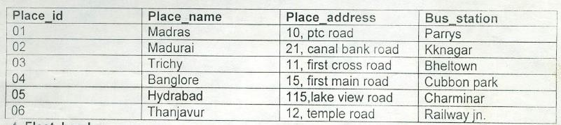
Fleet Header:
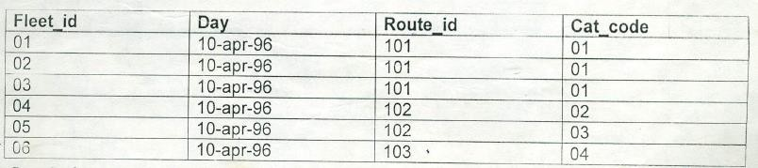
Ticket Header:
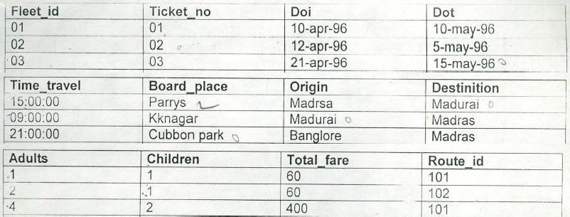
Ticket Detail:
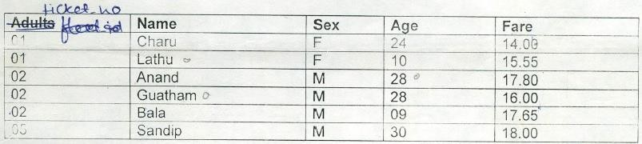
Route Detail:
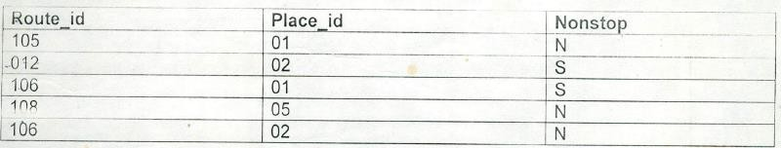
Queries:
    - Display all records of Category Header table.
    - Display place name and place address.
    - Check what will be the fare if it is incremented by 10 rs for each route. (Give new column alias as new_fare).
    - Display distinct destination from route header table. [Hint : Use ‘distinct’ keyword]
    - Display structure of table route detail. [Hint; Use ‘desc’]
    - Gautam’s fare got increased by 1 unit. Make changes in the appropriate table.
    - Write a query to change age of ‘Anand’ from 28 to 30.
    - Write a query to insert a new record into Route_Detail table with details as below:
      - Route_id: 105 , Place_id : 01, NonStop: S
    - Write a query to delete row inserted above from Route_Detail table.

PART B
(PART B: TO BE COMPLETED BY STUDENTS)
(Students must submit the soft copy as per following segments within two hours of the practical. The soft copy must be uploaded on the Blackboard or emailed to the concerned lab in charge faculties at the end of the practical in case the there is no Black board access available)
Roll No. : C172 | Name: Parva Gaglani
Class : D | Batch : D2
Date of Experiment : | Date/Time of Submission :
Grade :

B.1 Tasks given in PART A to be completed here
(Paste your answers and output here)
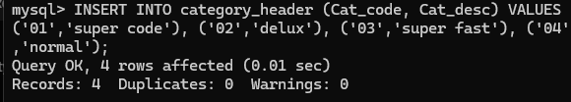
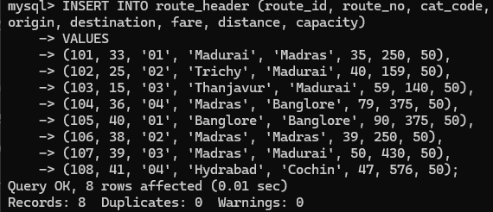
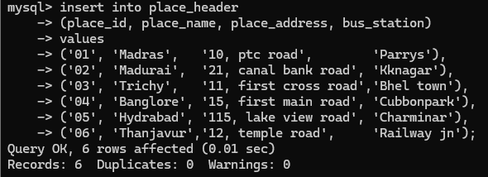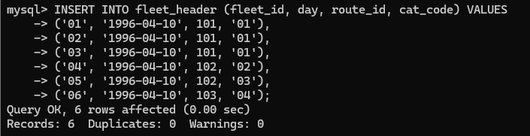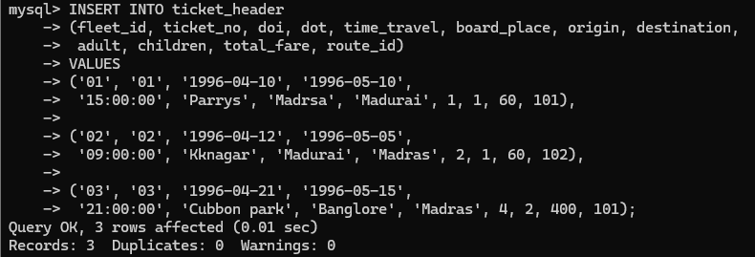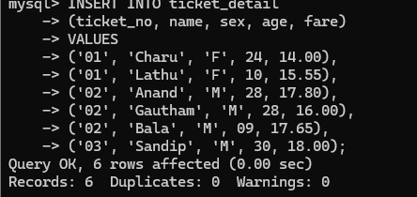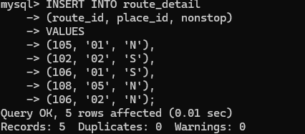
    - : Execution of each SQL query used to complete the task given in PART A:

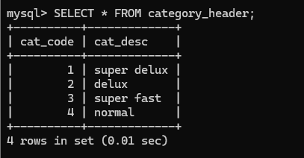

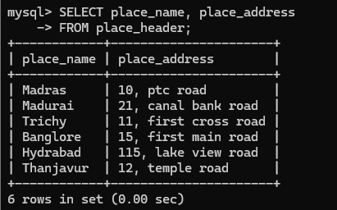

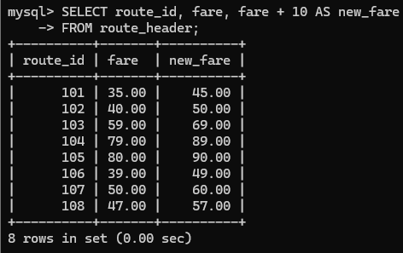

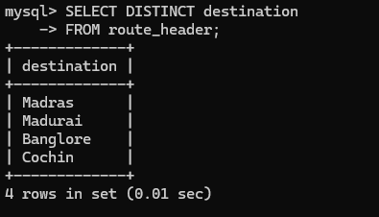

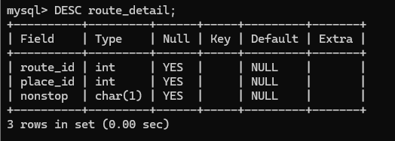

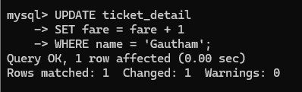

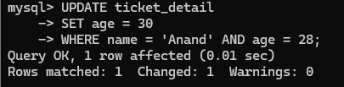

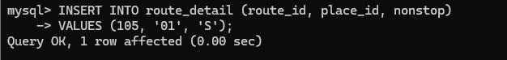

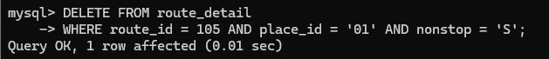

    - : Screenshots of the tables designed with constrains:

B.3 Observations and Learning:
(Students must write the observations and learning based on their understanding built about the subject matter and inferences drawn)

B.3 Conclusion:
(Students must write the observations and learning based on their understanding built about the subject matter and inferences drawn)

B.4 Question of Curiosity
(To be answered by student based on the practical performed and learning/observations)
- Differentiate between ‘ALTER’ and ‘UPDATE’ SQL Commands in used for Databases.
ALTER and UPDATE are SQL commands used for different purposes in databases. The ALTER command is a DDL (Data Definition Language) command that is used to change the structure of a table, such as adding, deleting, or modifying columns or constraints, and it does not affect the actual data stored in the table. In contrast, the UPDATE command is a DML (Data Manipulation Language) command used to modify existing data within a table by changing the values in one or more rows, without changing the table’s structure.

- Which other SQL DML Commands can be applied on the tables generated?
Other SQL DML commands that can be applied to the tables generated include INSERT, SELECT, and DELETE. The INSERT command is used to add new records to a table, SELECT is used to retrieve data from the table, and the DELETE command is used to remove existing records from the table.

